Ramapo Indian Hills
GRADE 12 Summer Reading 2019
*This assignment is for all students enrolled in English 4CP, English 4 CPE,
Dystopian Lit, Sports as Lit, Science Fiction, English Seminar, Myth and Culture, and
Film as Lit.
Students enrolled in English 4AP and SUPA courses should refer to separate assignments.
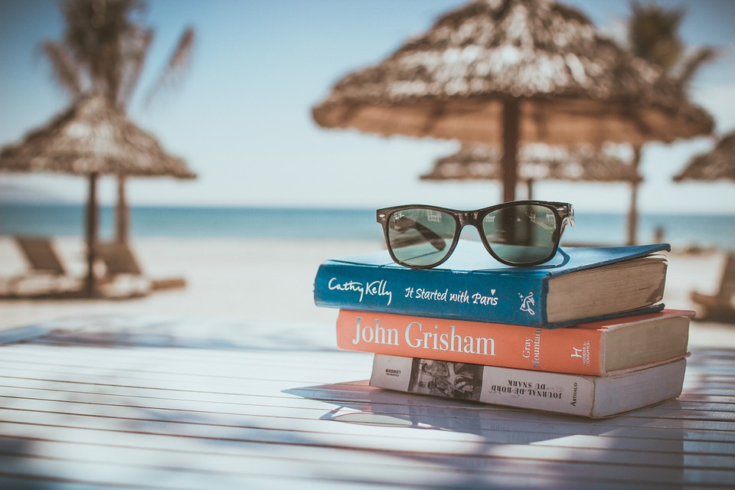

You can find magic wherever you look. Sit back and relax, all you need is a book! -Dr. Seuss

Reading is pleasurable and worthwhile. It offers you the opportunity to travel, to explore new places, and to experience a variety of interesting people and events all from the comfort of your own space. At the same time, reading a good book gives you a chance to practice your comprehension skills, to sharpen your reading rate, and to expand your vocabulary. Reading gives you the best of both worlds!

Please read the directions below:

- SELECT a book that you have not read before. It may be an intriguing new work of fiction, that dystopian novel your friends are talking about, or even a work of nonfiction about a subject you want to explore. Choose something that interests you! Consider consulting with your current teacher, school or town librarian, parents, and/or peers to help you with the selection process. You may also consult the ‘Book Selection Resources’ at the end of this assignment.

- ENJOY the read! You may wish (though it is not required) to take notes on the elements of narration (characters, setting, plot, conflict, themes, etc.) so that you can recall key points of your reading. You may also make notes or comments about your own personal responses, observations, or questions about what is happening in the book.

- REFLECT on your reading. Once you finish the book, write a one-page typed response. Briefly explain why you chose the book and then offer some reaction to it. This might be a personal, creative, or academic response---you decide! The important thing is that your response demonstrates the thinking that you did as a result of the reading. Whatever you do, do not simply summarize the book! (*Work will be submitted through Turnitin.com, an anti-plagiarism site, so be sure your work is original.)

- SHARE with your teacher and peers. Your thoughtful response to the book and your ability to discuss it in class will be the subject of one of the first assignments of school year. Your English teacher will provide more details in the first week of school. Just be sure to come to class with your book and a hard copy of your typed response on FRIDAY, SEPTEMBER 6, 2019.

SO GRAB YOUR SUNGLASSES... AND HAPPY READING!!!!

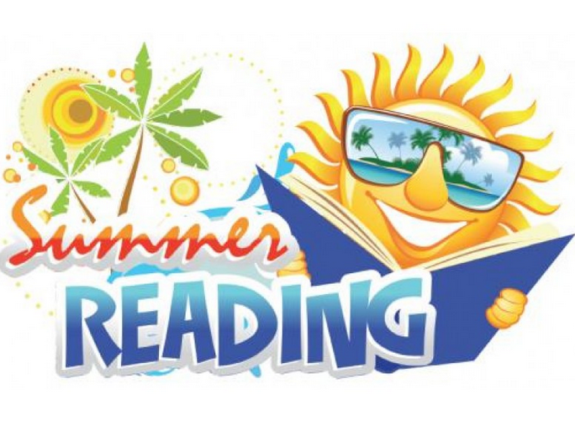

BOOK SELECTION RESOURCES

*Parents are urged to assist students in their text selections by consulting reviews at amazon.com and bn.com for additional information. Please be aware that some of the contemporary titles depict mature and/or controversial topics. Families are encouraged to review titles carefully prior to students’ text selection in order to choose the one that is the best fit for your student.

Websites:
https://www.barnesandnoble.com/blog/teen/the-best-young-adult-books-of-2017/
https://www.goodreads.com/list/show/43.Best_Young_Adult_Books

Suggested Titles:(*These are merely suggestions! Feel free to choose a book that is not on the list.)

- Scythe by Neal Shusterman**
- Dry by Neal Shusterman**
- Unwind by Neal Shusterman**
- 2001: A Space Odyssey by Arthur C. Clarke
- The Element : How Finding Your Passion Changes Everything by Ken Robinson
- What Made Maddy Run by Kate Fagan
- Where You Go Is Not Who You’ll Be: An Antidote to the College Admissions Mania by Ken Bruni
- Grit by Angela Duckworth
- Excellent Sheep: The Miseducation of the American Elite and the Way to a Meaningful Life by William Deresiewicz
- Fabricated: The New World of 3D Printing by Hod Lipson
- Bossypants by Tina Fey
- The Winter of our Disconnect by Susan Maushart
- Where Men Win Glory by Jon Krakauer
- 11/22/63 by Stephen King
- Middlesex by Jeffrey Eugenides
- Running with Scissors by Augusten Burroughs
- Cutting for Stone by Abraham Verghese
- Mountains Beyond Mountains by Tracy Kidder
- Galileo’s Daughter by Dava Sobel
- The Color Purple by Alice Walker
- The Godfather by Mario Puzo
- How to Read Literature Like a Professor by Thomas C. Foster
- How to Read Novels Like a Professor by Thomas C. Foster
- The 7 Habits of Highly Effective People by Stephen R. Covey

**The Fall 2019 Dystopian Literature class is strongly encouraged to read one of these novels as we are planning for the author, Neal Shusterman, to visit the school in November, 2019.

